

**Assessment 1: Business analytical report**

**Nintendo Co., Ltd**

Author: Bertocco Thomas-Killian - #13758322

Lecturer: Eddie Chng

CO5124 Data Analysis and Decision Modelling | SP52 | 2019

8 August 2019

Table of Contents

Introduction 4

SWOT analysis 5

Strengths 5

An established brand synonymous with gaming and entertainment 5

A large amount of data 5

Innovation 5

Nostalgia 6

Generalized distribution 6

Game Franchises 6

Capture unique markets 7

Cash Assets 8

Weaknesses 9

Data and analysis quality 9

Console failure 9

Loss of customers 9

Inability to respect margins 9

Third-Party Relationships 9

Less powerful consoles 9

Opportunities 10

Data analysis 10

New Segments 10

Growth of online systems 11

Infrastructure growth 11

Expanded audience 11

New product line 11

Threats 12

Data and privacy 12

hacking and data theft 12

Piracy 12

Intense competition from companies 13

Increased availability of counterfeit products in emerging markets 13

Innovation failure 13

Rapidly evolving technology 14

Recommendations 15

New ways to gather data 15

Maintaining the Switch 15

Increase hardware sales 15

Develop its mobile gaming sector 15

Conclusion 17

References 18

# Introduction

Established in 1889 as a small Japanese company producing handcrafted playing cards, Nintendo Company Limited is a Japanese multinational and one of the world's most giant video game and software companies. Headquartered in Kyoto, Japan, the company mainly manufactures entertainment products that are computer operated. As a video game specialist, Nintendo offers games in many categories and sells home consoles and handheld devices. Unlike its two competitors (Sony and Microsoft), a significant proportion of Nintendo games are created and developed in-house. Some of the largest video game franchises such as Mario and The Legend of Zelda are produced by the company. Nintendo is also co-owner of The Pokémon Company.

Nintendo has 5,944 employees worldwide (Nintendo, 2019).

In 2019, the company generated approximately USD 10.9 billion in net sales (Nintendo, 2019).

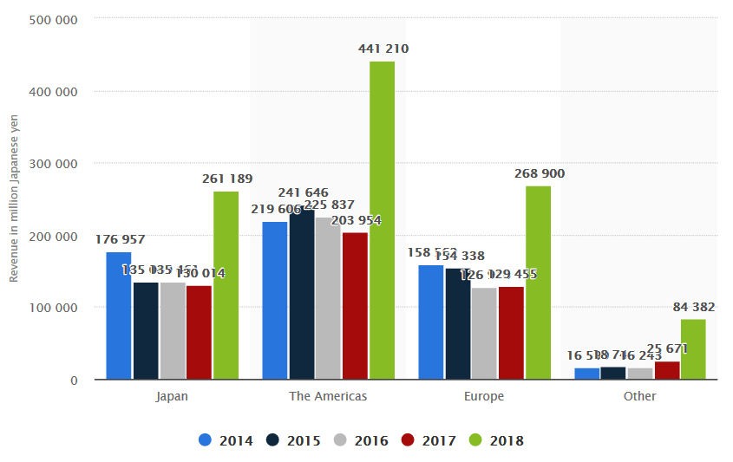

Figure 1. Nintendo revenue 2014 -2018, by region (Statista.com, 2018)

Most of Nintendo's revenue comes from the Americas, which contributed approximately US$4.5 billion in 2018 (Nintendo, 2019).

# SWOT analysis

## Strengths

### An established brand synonymous with gaming and entertainment

Nintendo is an established and popular brand all over the world and is synonymous with games and entertainment. It enjoys the trust and loyalty of his customers. Nintendo's core values (originality, flexibility, and sincerity) add to its strength and enable it to achieve its ambitious goals.

### A large amount of data

Thanks to its vast number of users on its online services, Nintendo has a significant amount of data about its products. The Nintendo Switch online alone counts more than 9.8 million accounts (Nintendo, 2019).

When users use one of Nintendo's online services, some of their personal information is collected and stored.

Various types of information are gathered (Nintendo, 2019):

* Any information the user provides when using the eshop or his account. This includes his name, e-mail address, telephone number, date of birth, country, language, gender, and time zone.
* Nintendo may collect data about the network (Internet provider, IP address, ...) or the switch itself (device model, serial number, operating system, ...)
* The location
* Information about playing habits, history of use of Nintendo services, and relations between users.
* Anything the user upload to Nintendo services, such as text messages, images, or videos.
* Purchases, including account and credit card information, as well as the billing addresses.
* Crash reports

For advertising, Nintendo uses third-party companies (e.g., Facebook, Google, Amazon) to collect information.

Nintendo also gathers sales data from retailers and eshops.

### Innovation

One of the main reasons Nintendo has been able to compete with its competitors is that it has not been afraid to innovate throughout its history. Various products such as the Nintendo DS, Wii / Wii U, and Switch have all brought something new to the gaming industry and have helped the company to dominate or compete in various market segments.

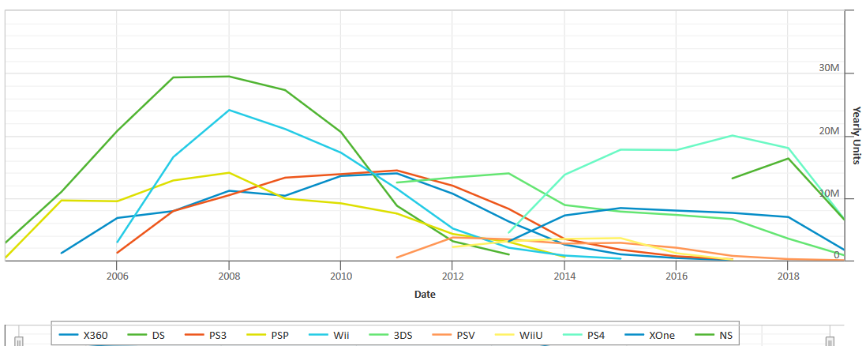

Figure 2. Yearly Hardware Comparisons - Global (Vgchartz.com, 2019)

The dual-screen DS monopolized the pocket game market when it was released because of its innovative and easy-to-use nature, and various console updates have given the product a long lifespan. The Wii used the motion control technology that Nintendo introduced to the market to differentiate itself from its competitors. The DS and the Wii are both in the top 5 of the best-selling consoles of all time (Wikipedia, 2019).

### Nostalgia

Nintendo is one of the great pioneers of video games. As such, many players who started playing Nintendo games 20 years ago are still as loyal to the company and its characters today.

### Generalized distribution

Nintendo has a pervasive distribution network and distributes its products through both wholesalers and retailers. The company also sells through its stores and even through various high-end retailers. Nintendo products can also be purchased through Amazon and other online retail sites.

### Game Franchises

Throughout its history, Nintendo has maintained the popularity of its consoles through exclusive characters and game franchises.

For example, in addition to being known worldwide, Mario (596 million sold) and Pokemon (340 million sold) are the two best-selling Franchises in history (Wikipedia, 2019).

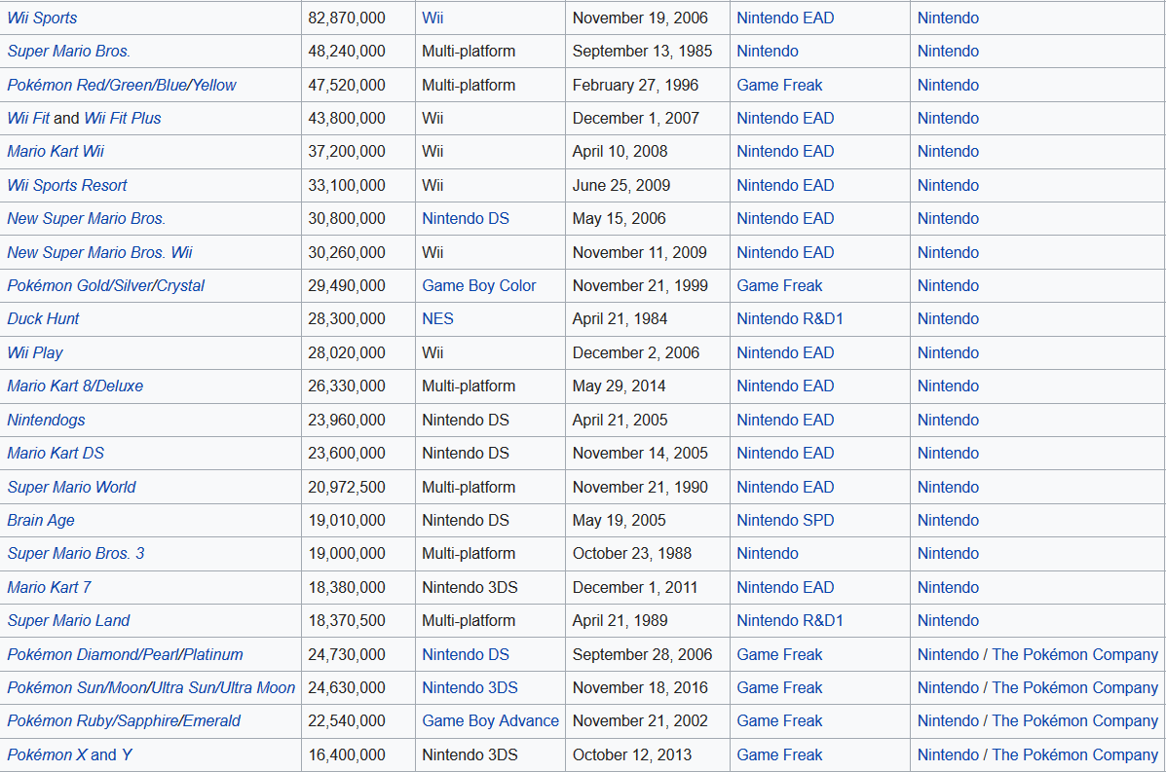

Figure 3. List of best-selling video games (Wikipedia.org, 2019)

In the top 50 rankings of best-selling video games, we can observe that 19 games published by Nintendo.

Many other names such as donkey kong and Yoshi have sold products to all four corners of the globe.

In addition to this, Nintendo has maintained close relationships with many external and independent development studios, to ensure that other major franchises such as Sonic, Final Fantasy, Call of duty, remain available on their machines.

With over 4.7 billion games sold since its inception (Nintendo, 2019), the success of Nintendo's franchises is undoubtedly a crucial part of their history and success.

### Capture unique markets

One of Nintendo's significant competitive advantages is that it targets young players, families, and casual players in addition to hardcore players.

While Sony and Microsoft are racing to produce the most technically impressive consoles to capture hardcore players, Nintendo has chosen to focus on innovation and less competitive games.

Thanks to its innovative technology and game catalog, Wii was the first to welcome players of all ages and types.

### Cash Assets

Nintendo has a large number of cash assets at its disposal. Despite the drop-in stocks during the Wii U era, Nintendo was able to maintain up to $10.5 billion in cash assets reserves in 2012 (Nintendo, 2012). At the start of 2019, Nintendo still had about $7.7 billion in cash assets, enough resources to operate at a loss for a few years (Nintendo, 2019b). This liquidity reserve gives it two advantages: on the one hand, it allows it to continue to innovate and take risks, and on the other hand, it will enable it to remain concentrated in the use of its resources, since Nintendo is only a gaming company, unlike its main competitors.

## Weaknesses

### Data and analysis quality

One big problem of data is the risk of bad quality conclusions gathered from the data. With the massive amounts of data available in this kind of analysis, it is easy for data scientists to make mistakes.

In addition to human mistakes, there is no way to verify the authenticity of the data (e.g., user age, location) the information analyzed may be false, and given rise to wrong conclusions.

### Console failure

Nintendo's best-selling product is its Wii game console. The game console has several limitations, and this has led to a massive product failure that has caused a lot of loss for the company.

### Loss of customers

The company performed poorly after the Wii U console fiasco, causing the customer to lose confidence in the company. Even the brand's loyal customers have started to switch to other brands.

### Inability to respect margins

Games are a low-margin business, and Nintendo has to look at volumes to make a profit. However, due to increased competition from large and small players, margins are becoming increasingly difficult to satisfy.

Overall, Nintendo has low margins, with about 17% of margins in 2018.

### Third-Party Relationships

Despite recent improvements, Nintendo is still struggling to obtain major licenses on its platforms, as external publishers do not dare to adapt their games to technically limited consoles.

### Less powerful consoles

Nintendo still produces consoles with lower hardware characteristics than competing consoles. This keeps both hardcore players who want good graphics quality away, and third-party developers whose games are too powerful for Nintendo consoles.

## Opportunities

### Data analysis

Nintendo uses every level of analytics. The data it gathers is analyzed to understand the market, predict games/consoles success, make internal decisions about their business strategy, and how to market games. It also uses it to create and improve services, offer customized content, and fix bugs.

For personalized advertising and suggestions, Nintendo uses third-party companies to analyze information. Those companies use web beacons, software development kits, cookies and other technologies to track the content or ads that the user views, how he responds to the ads they show him, how much time he spends on different pages and how he arrives on a particular page.

### New Segments

With the increasing use of virtual reality and mobile gaming, the scope of games increases as the number of segments increases. Today, video game companies can target anyone, from young children to adults and even the elderly. The number of active mobile players will reach 1.24 billion in 2023.

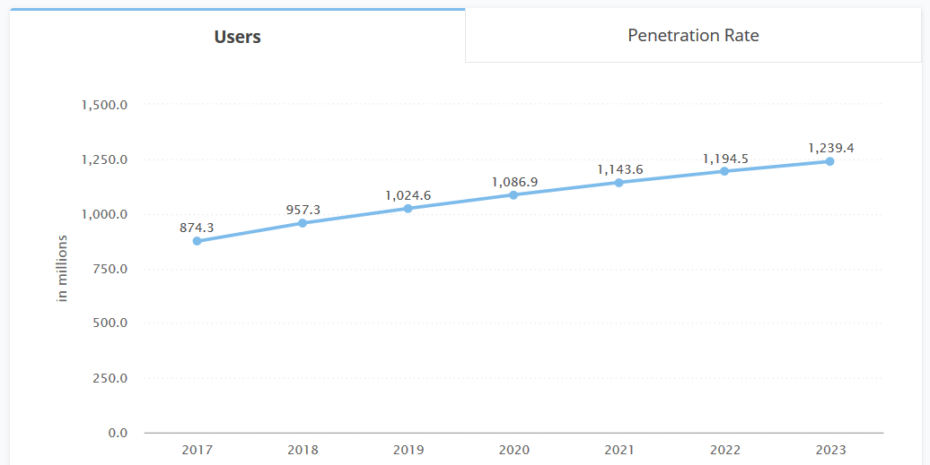

Figure 4. Mobile games users in millions (Statista.com, 2019)

Besides, it offers new markets for Nintendo to use their intellectual property to capitalize on new trends and grow its gaming market segment outside of just the console segment.

### Growth of online systems

With a large number of cash assets, Nintendo has the opportunity to extend the functionality of today's online systems. Nintendo can also use the popularity of the Switch to attract more online applications and services, such as Netflix and Twitch, to join the platform.

### Infrastructure growth

The growth of infrastructure such as Internet bandwidth in remote and isolated locations has contributed to the increase in the number of game users.

### Expanded audience

If the Switch can bring back the hardcore gamer audience lost over the past decade, Nintendo has the opportunity to significantly expand its customer base. Instead of creating a console dedicated to casual players or trying to bring back hardcore players, the Switch is more of a hybrid that will please both. Nintendo has partnered with companies such as Activision, Bethesda, and Ubisoft, among others, whose games were not always designed for Nintendo systems.

### New product line

In the fall of 2014, Nintendo launched the Amiibo(s), toys related to the company's video games. Some of these toys were designed to be electronically compatible with video games, and this feature helped toys reach sales of 21 million units worldwide during its first fiscal year. By continuing to diversify and improve this product, Nintendo should be able to improve on this success.

## Threats

### Data and privacy

The data collection is not always well received by consumers. Nintendo collects all the players' actions: their purchases, game times, friends, messages, etc.

Also, some of this data is transmitted to external companies for advertising and marketing purposes.

Some users are reticent about these methods and may refuse to buy Nintendo products because of this.

### hacking and data theft

Like all companies, Nintendo is the target of many computer attacks. The risk that a hacker may succeed in penetrating the servers and stealing data cannot be ignored. This type of leak could damage the company's reputation and cause significant loss.

In 2014, one of its main competitors, Sony, suffered an attack leading to the publication of millions of data, including passwords and credit card numbers.

### Piracy

Illegal content downloading is present on all types of platforms. Nintendo consoles have a relatively low-security level, so it only takes hackers a few months to remove protection and allow users to use downloaded games. The loss due to illegal downloading amounts to several billion dollars.

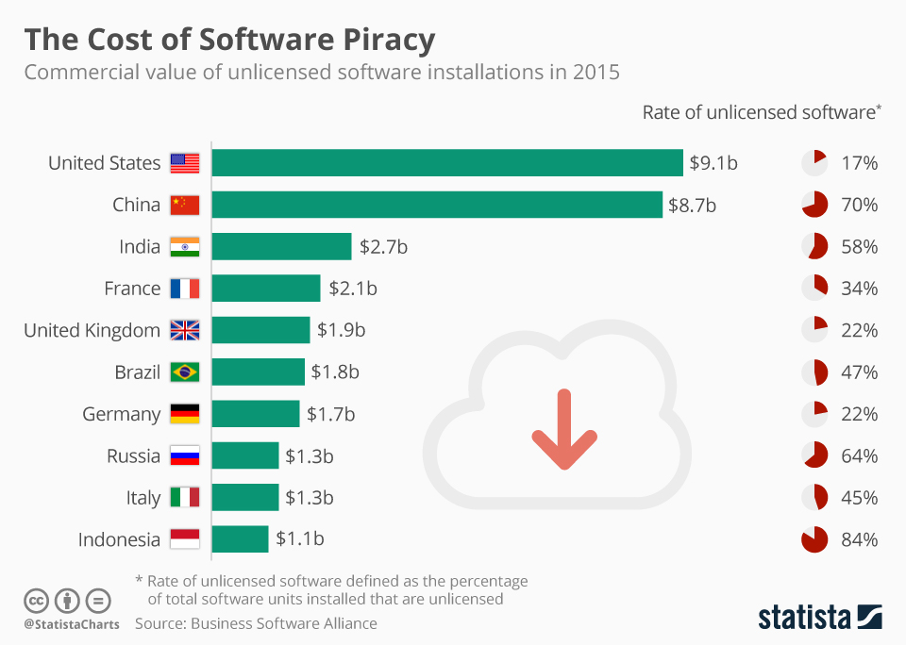

Figure 5. The Cost of Software Piracy (Statista.com, 2015)

### Intense competition from companies

Nintendo faces strong competition from Sony and Microsoft, which offer more versatile and multi-purpose game consoles that can be used for entertainment purposes such as online navigation and streaming. Additionally, alternative gaming avenues such as PC, virtual reality, and mobile gaming threaten Nintendo as substitute goods for the company's console hardware and software.

### Increased availability of counterfeit products in emerging markets

Counterfeit video game consoles are increasingly being shipped internationally, with one in four products shipped being distorted according to an OECD report. The primary source of these fake products is China, where copyright laws are rarely enforced and infringement is widespread.

E-commerce platforms such as Amazon and Alibaba have provided an easy way to get these products where they are available at low prices.

Thus, the increase in counterfeits not only leads to a loss of revenue for Nintendo but also makes it difficult to expand Nintendo's business and grow in emerging markets where counterfeits are preferred by consumers due to low prices.

### Innovation failure

Although successful innovation can generate sales and attract new customers to Nintendo products, there is always the risk that a new product will be considered a failure. A good example can be seen in the successor to Wii, the Wii U, which generated low sales compared to its predecessors. As you can see on the chart below, the Wii U is not the only example.

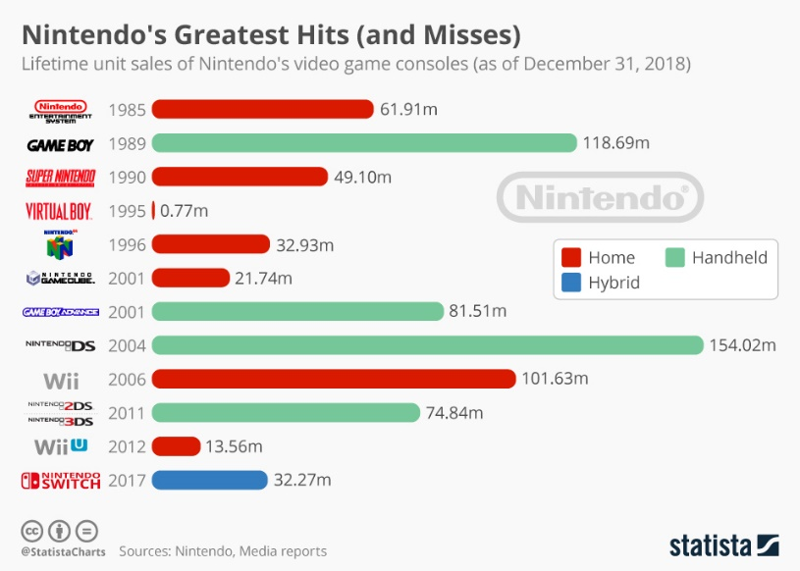

Figure 6. Nintendo's Greatest Hits (and Misses) (Statista.com, 2019)

### Rapidly evolving technology

Technologies are constantly evolving, and new technologies are emerging, which requires Nintendo to integrate new trends into its existing systems to keep their products up to date. New technologies such as the Google Stadia game streaming service threaten to revolutionize the gaming industry as Netflix has done for the film and television industry.

# Recommendations

## New ways to gather data

Nintendo should find new ways to collect information about its users in order to better understand their expectations. By developing new types of products, the company could collect different kinds of data. For example, it could create a social network accessible from its consoles, through which players could interact with each other, create groups, post messages, etc.

The more information Nintendo has, the more it will be able to develop consoles and games that meet market demand.

## Maintaining the Switch

Nintendo should continue to build on the success of the Switch, by continuing to develop its catalog of video games throughout the console's life. These games should include new franchises, known franchises, further exclusivities and popular games from third-party publishers.

## Increase hardware sales

Nintendo releases a new system every 4 - 5 years. In order to increase its hardware sales, the company will soon offer a lite version of the Switch, with fewer features, but at a lower price.

I think Nintendo should develop a Pro version of the Switch that would offer longer battery life, a better screen, and an improved graphics card. The Switch Pro would be sold for $349. The Pro version would be aimed at hardcore and wealthier players.

## Develop its mobile gaming sector

Nintendo must continue to develop its mobile gaming sector, producing several mobile games each year. New mobile games could be divided into three categories:

- Existing franchises such as Mario, Zelda, or Splatoon.

- Old remastered games like Pokemon or Kirby.

- New franchises

Whatever the game, Nintendo should continue to use a free microtransaction system for its mobile games, giving players enough free content to get them involved in the game while enjoying more involved players.

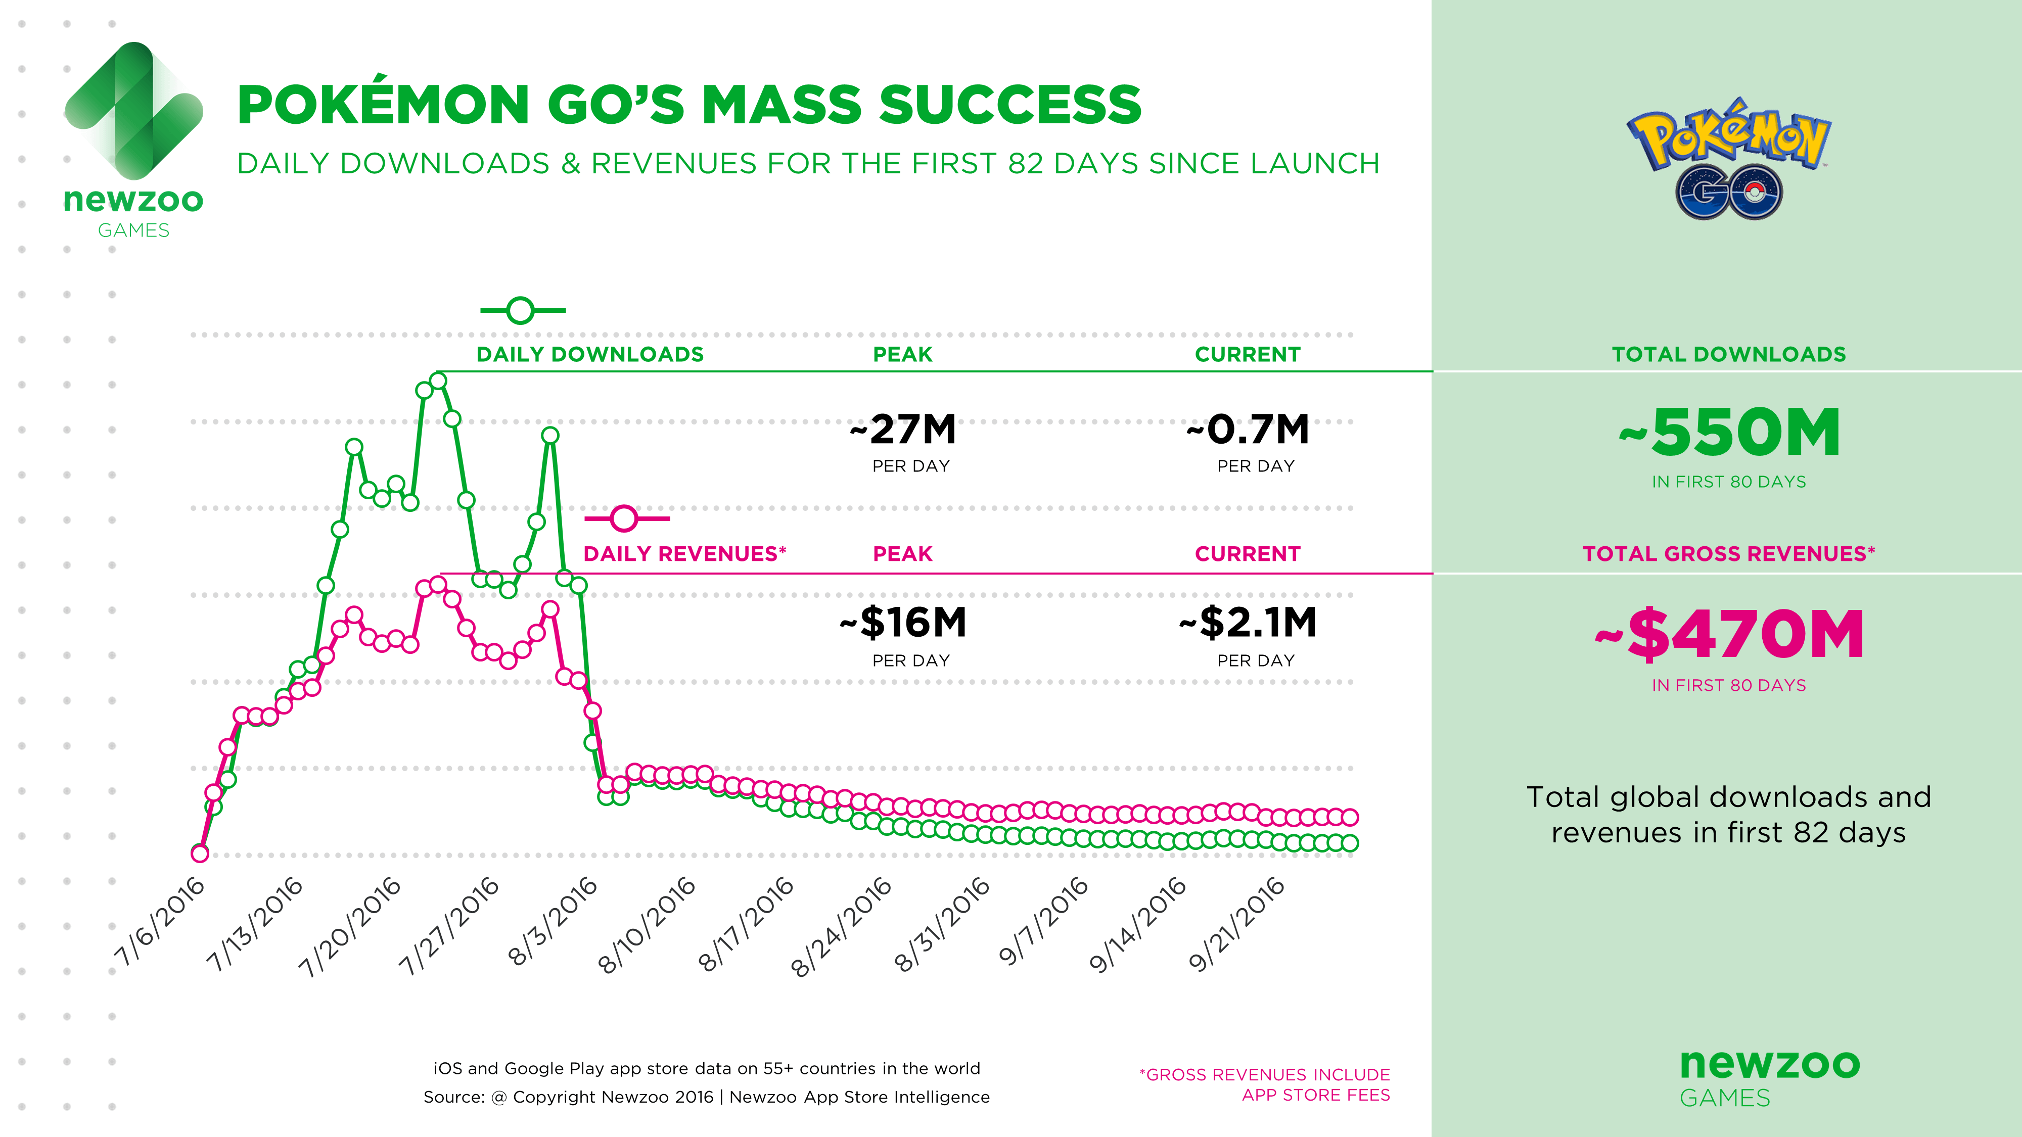

Figure 7. Analysis of Pokémon GO: A Success Two Decades in the Making (Newzoo.com, 2016)

Pokemon Go is the proof that the growth of Nintendo's mobile games segment would lead to a significant increase in revenues and profits, and cash flow potential since games would not have any physical costs associated with game distribution and would contribute to increasing Nintendo's total market share in the video game market.

## Begin Next-Gen R&D

Nintendo should start looking at the research and development of its next generation of consoles, as its competitors have already begun to tease information about their next consoles. If Nintendo does not react, its products could be technologically outdated.

# Conclusion

Nintendo is a reliable company, established for many years. Its choice to bet on innovation rather than power has allowed it to stand out, and to reach a single market.

However, its innovation strategy involves considerable risk, as it is tough to predict in advance whether customers will like it or not. The failure of the Wii U is a clear example of this.

Business analytics has a very important place in the company, because it allows them to analyze the behavior of its users and adapt its products.

Thanks to the success of its products, and its reserves of funds, the company should still shine for many years to come.

# References

Liu, S. (2019, April 10). *Nintendo - Statistics & Facts*. Retrieved from Statista.com: https://www.statista.com/topics/2284/nintendo/

Newzoo. (2016, September 30). *Analysis of Pokémon GO: A Success Two Decades in the Making*. Retrieved from Newzoo.com: https://newzoo.com/insights/articles/analysis-pokemon-go/

Nintendo. (2017, September). *Nintendo Privacy Policy*. Retrieved from Nintendo.co.jp: https://www.nintendo.com/privacy-policy/

Nintendo. (2019). *Annual Report 2019.* Kyoto: Nintendo. Retrieved from https://www.nintendo.co.jp/ir/pdf/2019/annual1903e.pdf

Nintendo. (2019, March 31). *Historical data*. Retrieved from Nintenco.co.jp: https://www.nintendo.co.jp/ir/finance/historical_data/xls/consolidated_sales_e1906.xlsx

Nintendo. (2019). *Nintendo Corporate Information*. Retrieved from Nintendo.co.jp: https://www.nintendo.co.jp/corporate/en/index.html

Nintendo. (2019). *Nintendo Investor Relations Information*. Retrieved from Nintendo.co.jp: https://www.nintendo.co.jp/ir/en/index.html

*Nintendo Co., Ltd. (NTDOY)*. (2019). Retrieved from Yahoo Finance: https://finance.yahoo.com/quote/NTDOY?p=NTDOY

Statista. (2015). *The Cost of Software Piracy* . Retrieved from Statista.com: https://www.statista.com/chart/5164/use-of-unlicensed-software/

Statista. (2018). *Nintendo revenue 2014 -2018, by region*. Retrieved from Statista.com: https://www.statista.com/statistics/216627/revenue-of-nintendo-by-region/

Statista. (2019). *Mobile Games*. Retrieved from Statista.com: https://fr.statista.com/outlook/211/100/mobile-games/worldwide

Statista. (2019, April 18). *Nintendo's Greatest Hits (and Misses)*. Retrieved from Statista.com: https://www.statista.com/chart/6338/nintendo-game-console-sales/

Vgchartz. (2019). *Yearly Hardware Comparisons - Global*. Retrieved from Vgchartz.com: http://www.vgchartz.com/tools/hw_date.php?reg=Global&ending=Yearly

Vgchartz. (n.d.). *Yearly Hardware Comparisons - Global*. Retrieved from Vgchartz.com: http://www.vgchartz.com/tools/hw_date.php?reg=Global&ending=Yearly

Wagner, E. (2019, April 8). A Strategic Audit of Nintendo Co., Ltd. *University of Nebraska-Lincoln*. Retrieved from https://digitalcommons.unl.edu/cgi/viewcontent.cgi?article=1149&context=honorstheses

Wikipedia. (2019). *List of best-selling game consoles*. Retrieved from Wikipedia.org: https://en.wikipedia.org/wiki/List_of_best-selling_game_consoles

Wikipedia. (2019). *List of best-selling video game franchises*. Retrieved from Wikipedia.org: https://en.wikipedia.org/wiki/List_of_best-selling_video_game_franchises

Wikipedia. (2019). *List of best-selling video games*. Retrieved from Wikipedia.org: https://en.wikipedia.org/wiki/List_of_best-selling_video_games

Wikipedia. (2019). *List of best-selling video games*. Retrieved from Wikipedia.org: https://en.wikipedia.org/wiki/List_of_best-selling_video_games